**Student Achievements**

1. Leeza Das, student of 3rd semester, Department of Zoology has bagged the 3rd prize in Poster Presentation organized by DDR College, Chabua on the occasion of National Science Day.

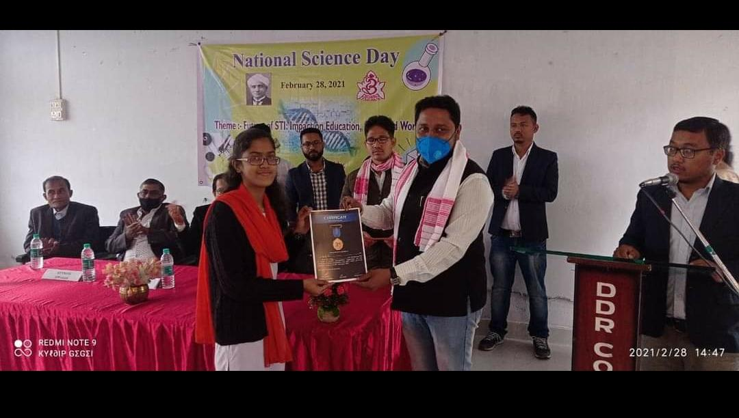

1. Karishma Baishnabi won the first prize in the book review competition held at Chowkidingee field on 4th March, 2021.
2. NCC cadets of the college from 63 Assam Girls’ Bn NCC secured second position in parade in republic day celebration of Chowkidingee field of Dibrugarh district on 26th January, 2022.

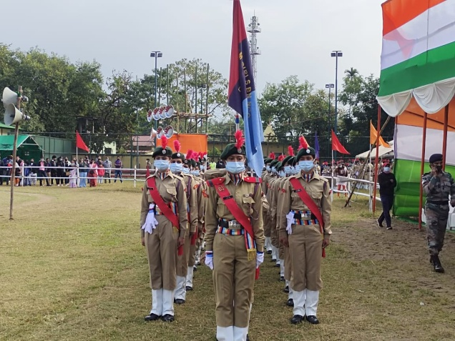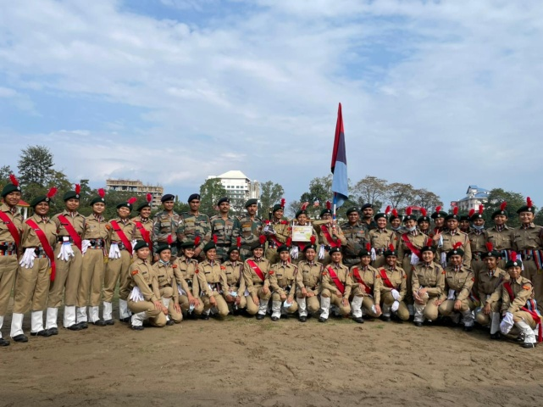

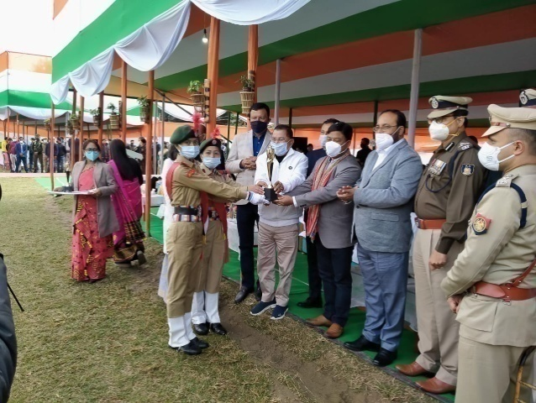

1. The YOUTH FESTVAL cultural rally was held on 6th April,2022.

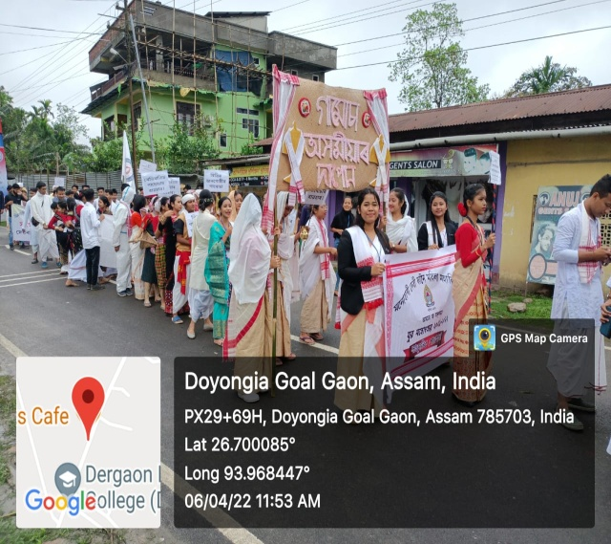

1. Participation of students in Dibrugarh University youth festival held in DKD College, Dergaon on 3rdto 6thApril,2022.

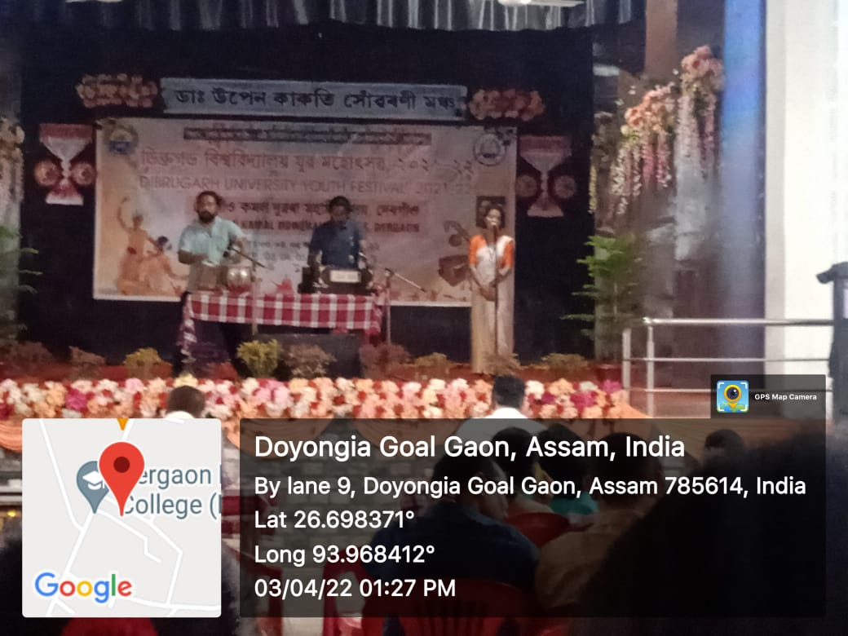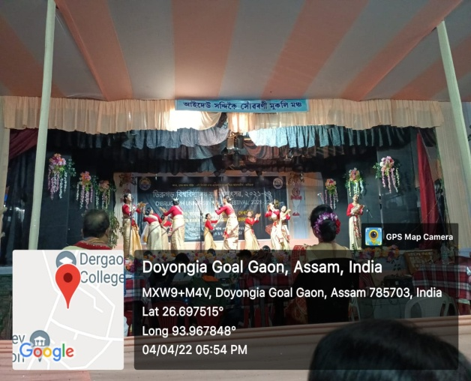

1. Students participants secured 1st prize in cultural procession of youth festival held in Dergaon DKD College on 6th April,2022

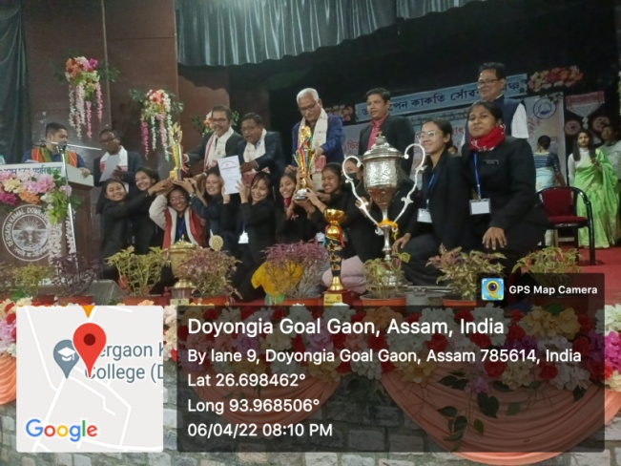

1. Miss Shainee Sonowal of MDKG College got 2 gold medals in intercollege karate competition held at Dibrugarh University 27th April,2022.

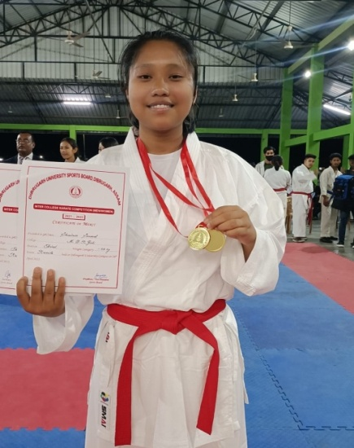

1. Miss Sunita Deori of third semester student of sociology department of MDKG College won gold medal(Senior U-53 KGFemale) and won Bronze medal in Senior Girls Group Poomsae in 37th All AssamState Taekwondo Championship 2022 held from 17th August to 20tyh August,2022.

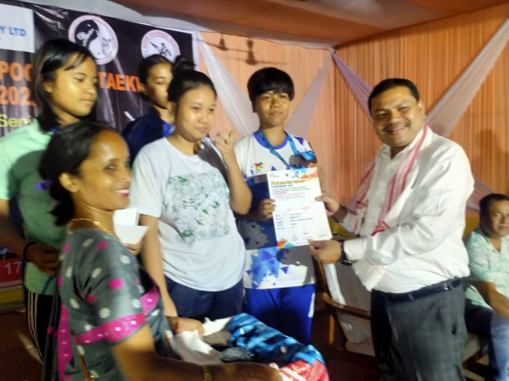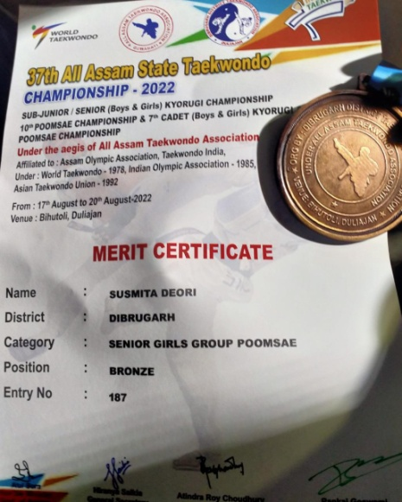

1. Leena Sen won 1st position in weight category 52-54 kg event Dibrugarh University sports board, Dibrugarh, Assam on 24th to 28th December, 2022.

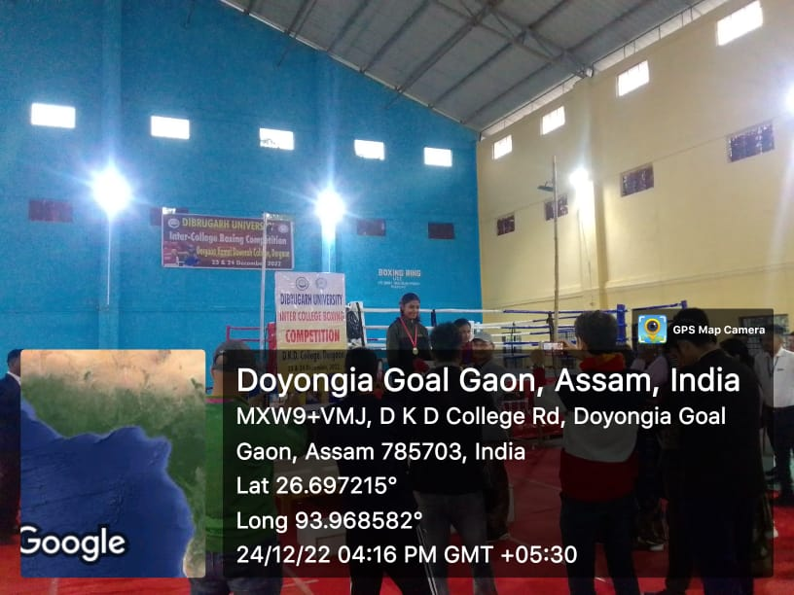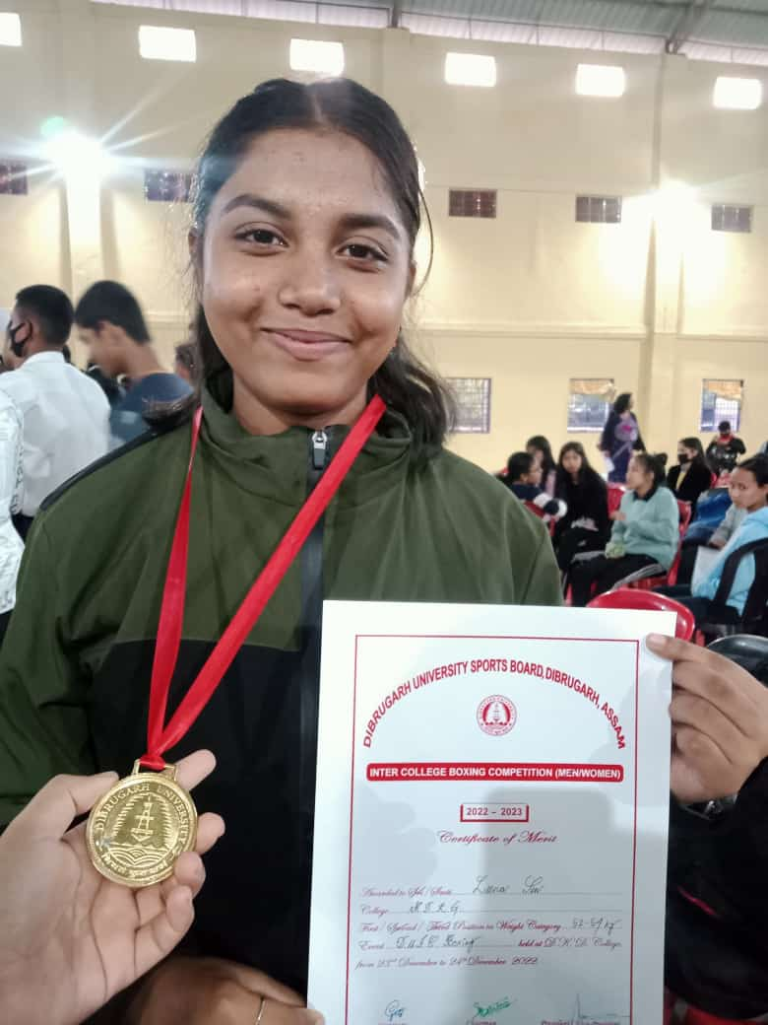

1. 30th December, 2022 Khusi Lohan won 1st position in weight category 49 kg in the event weight lifting (women) held on 29th December, 2022.
2. Wushu Broze by Pallabi Dhar of MDKG College (7th January, 2023)

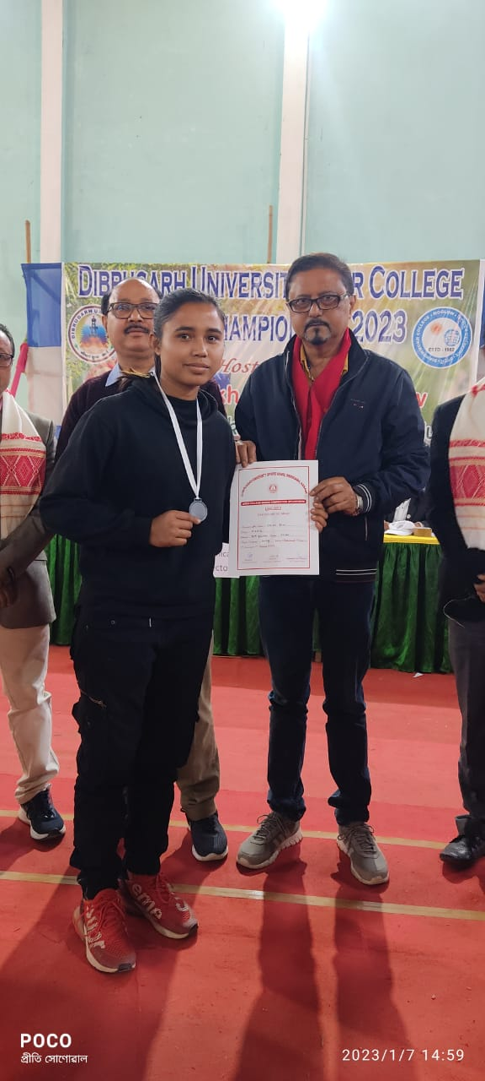

1. First prize 63 Assam Girls Bn NCC on 26th January, 2023

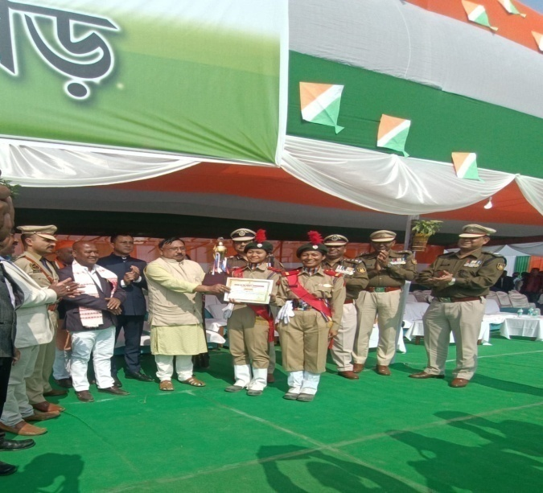

1. The result of the essay competition held on the occasion of Bir Chilarai Divas (13thfeb, 2023).
2. Sushmita Deori won silver medal (weight category under 62 kg) held at Moran Mahila Mahavidyalay from 15th to 16th October, 2023.

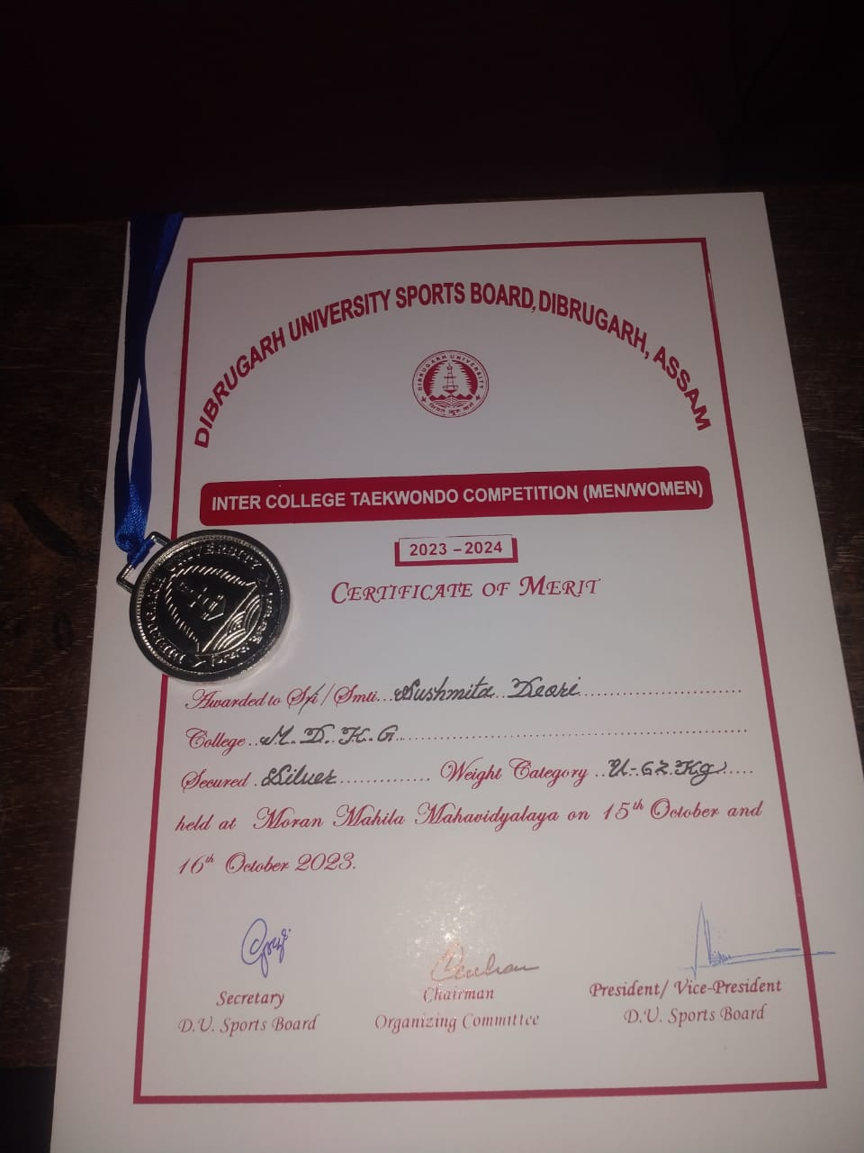

1. Farnaz Begum of MDKG College secured 2nd position in book review competition in inter-college literary competition in youth festival of Dibrugarh University at LTK College on 25th January, 2024.

